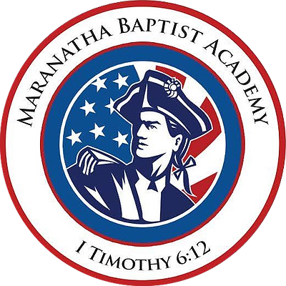Maranatha Baptist Academy
205 Stateline Rd, Oak Grove, Ky, 42262 931.302.8091 mbaoakgrove.com

July 2019

Dear Parents,

I am writing this letter to you, because the summer will be gone before you know it. I trust you are enjoying the different pace that summer brings. Enclosed you will find a calendar and other information that might be helpful to you as you prepare for the school year.

Please note the following items:

School Supplies:

A school supply list for grades 1-12 is enclosed with this letter. When buying supplies such as lunch boxes, backpacks and folders, please use discretion. Do not buy cartoon characters that are questionable. If you are not sure about a cartoon character, you may call the school office.

Open House:

We will have Open House on Friday, August 9, 2019 from 5:00-7:00 p.m. Parents may come by and meet with your child’s teacher anytime during those hours. School begins Monday, August 12, 2019 at 8:00 a.m. The school calendar is enclosed.

Books/School Tech Fee:

The book fee must be paid before books will be ordered for your student. Please contact the office if you have any questions. MySchoolWorx is a computer program that will allow parents immediate access to their child’s grades, homework assignments and teh ability to communicate with your child’s teacher. There will be a $50 tech fee charge per family. We believe this program enhances our ability to communicate more effectively with parents. Please contact the office if you have any questions.

School Uniforms:

Students in all grades wear school uniforms. Uniform guidelines: Polo shirts may be short or long sleeved. Chapel dress: Boys 1st-12th must wear dress shirt and tie. Girls 1st-12th can wear school uniform or any style “church dress.” Just a reminder: Girls K3-12th grade may not wear pants and skirts can be no higher than the kneecap or the back of the knee. Dresses with spaghetti straps, sleeveless, or open shoulder tops are not permitted. Shorts may not be worn for uniform dress. Parents should see the handbook for uniform guidelines.

Teachers will do a daily dress check and students must wear this uniform. Call the school office if you have any questions.

Attendance, Tardies & Early Dismissal:

Early Pick Up - The handbook states that full day students will not be dismissed until 3:00 pm. Last year we had parents coming early but we are asking that you abide by the 3:00 pm dismissal time except for appointments that can not be scheduled later in the day.

Attendance & tardies - When students are absent or late to school, they are missing direct instruction from the teacher that can never be totally recaptured. Regular school attendance is a part of the learning process. Students, parents, and the community all benefit when students are on time to school. Reminder for grades 7-12: On the fourth and subsequent unexcused tardy of each quarter a detention will be given that will be served during PE or after school. Please help us by having your student at school and on time.

High School Schedule:

For students in grades 7-12, the high school schedule is enclosed. Please look over the schedule and let the office know which elective classes your student will be taking.

Thank you for taking the time to read this letter. If you have any questions, please call the school office at (931) 302-8091 or Dan Delaney at (502) 386-5524.

Sincerely in Christ,

Dan Delaney
School Administrator

